

Faculty of Commerce and Accountancy

Master of Business Administration
(English Program) # ……………
Special Project - Proposal Form

First name/Last name__________________________________ID number____________________

ชื่อ / นามสกุล..................................................................................................................................................................................................

IS Title (English) _________________________________________________________________________________________
หัวข้อ (ภาษาไทย)
________________________________________________________________________________________________________________
Type of Project
⃞ Business Plan ⃞ Strategic Plan ⃞ Research Project ⃞ Case Study
Student’s Signature ________________________________________
( )
Date _______________________________

Advisor’s comment
______________________________________________________________________________________________________________
______________________________________________________________________________________________________________
______________________________________________________________________________________________________________
Advisor’s Signature __________________________________________
( )
Date ______________________________

Director’s comment
________________________________________________________________________________________________________________
________________________________________________________________________________________________________________
________________________________________________________________________________________________________________
Director’s Signature ________________________________________
( )
Date ____________________________

Rationale for the Study
This is the sample of the content.
For the whole content from Chapter 1 -4, LEFT margin is 1.5 inch. RIGHT margin is 1.0 inch. Tab is 0.5 inch.
The line space for the whole content is 1 spaces.
The line space in the table is single space.

Font size of IS Document
Form letters in Thai : Cordia New 16.
Font letters in English : Cordia New 16.
The Page Setup : 1-inch stem on the bottom left of the 1.5 -inch, 1 inch, 1 inch right . However, students can format the page, as well as appropriate major topic subsections size or spacing between lines.

Objectives of the Study
The objectives of this independent study are
  - To explore xxxxxxxxxxxxxxxxxxxxxxxxxxxxxxxxxxxxxxxxxxxxxxxxxxxx
  - To examine xxxxxxxxxxxxxxxxxxxxxxxxxxxxxxxxxxxxxxxxxxxxxxxxxxxx
  - To understand xxxxxxxxxxxxxxxxxxxxxxxxxxxxxxxxxxxxxxxxxxxxxxxxxx

Scope of the Study
xxxxxxxxxxxxxxxxxxxxxxxxxxx. This is the sample of the content. This is the sample of the content.xxxxxxxxxxxxxxxxxxxxx

Methodology of the Study
- Sample………………………………………………………………………………………....................
- Sample…………………………………………………………………………………………

Contribution of the Study
- sample of the content
- Sample of the content
- Please use Time New Roman 11 or 10, single space for the font in each table. Example

Time frame of the study
Activities | Apr |  |  |  | May |  |  |  | June |  |  |  | July |  |  |  | Aug |  |  |  | Sep |  |  |  | Oct
Activities | 1 | 2 | 3 | 4 | 1 | 2 | 3 | 4 | 1 | 2 | 3 | 4 | 1 | 2 | 3 | 4 | 1 | 2 | 3 | 4 | 1 | 2 | 3 | 4 | 1 | 2 | 3 | 4
1) …………….
2) …………….
3) …………….
4) …………
5) ………..
…
…
…
… |  |  |  |  |  |  |  |  |  |  |  |  |  |  |  |  |  |  |  |  |  | X
 |  |  |  |  |  |  |  |  |  |  |  |  |  |  |  |  |  |  |  |  |  |  |  |  |  | X

Notice :
Please use Arabic page number at the right bottom of each page
Please make left alignment for Tables
Please make center alignment for Figures

MBA Program
Faculty of Commerce and Accountancy, Chulalongkorn University
Guide for Independent Study

Subject Description

2600700 Special Project 3(0-0-12)
SPECIAL PROJECT
Independent study for business administration problem.

Type of Topic :

    - Research Project
    - Feasibility
    - Case Study
    - Business Plan / Strategic Business Plan

Steps for Developing and Filing an Independent Study Plan
- Students make decision for Topic
- Contact Advisor
- Submit a proposal
- Conduct the study
- Submit 1st draft paper (3 copies) for Presentation Exam
- Presentation Exam
- After Student pass an exam, be prepare to submit Final Report (2 copies).
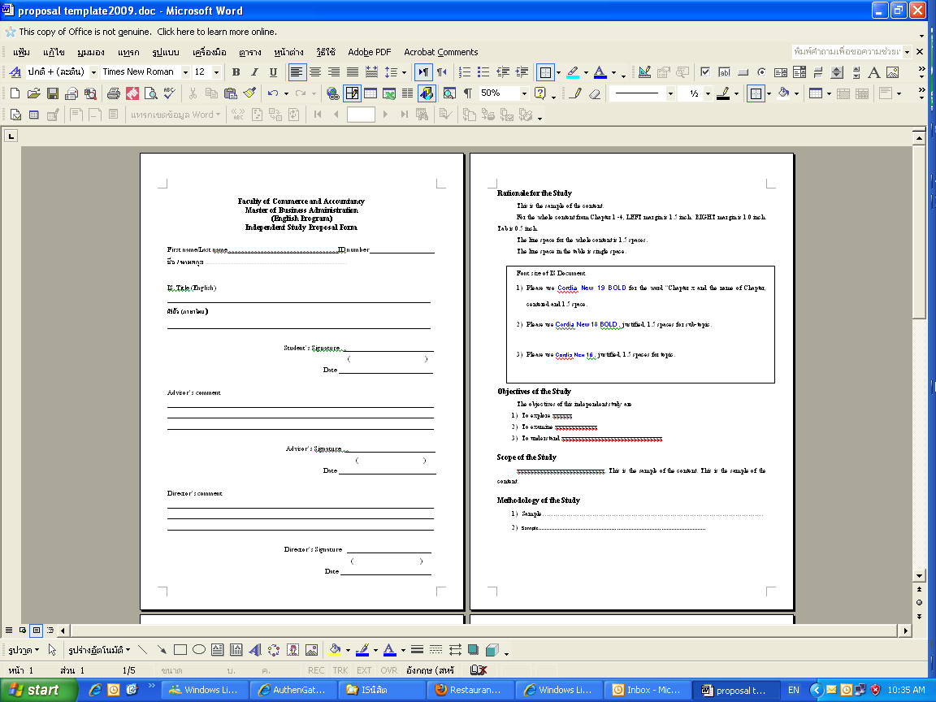
You can download a new one of Independent Study Proposal Form
From https://mba.cbs.chula.ac.th/student/

